Hw 06 – documentation

----------------------------------NO CHANGES-------------------------------------------------------------

without training:   
['test_loss: 2.300455331802368', 'test_acc: 0.09939999878406525']

Epoch 0:  
['train_loss: 2.1869802474975586', 'train_acc: 0.18012000620365143']  
['test_loss: 2.0353763103485107', 'test_acc: 0.23000000417232513']

Epoch 1:  
['train_loss: 1.9378968477249146', 'train_acc: 0.27008000016212463']  
['test_loss: 1.8695058822631836', 'test_acc: 0.2973000109195709']

Epoch 2:  
['train_loss: 1.8155757188796997', 'train_acc: 0.3151000142097473']  
['test_loss: 1.796432375907898', 'test_acc: 0.3172000050544739']

Epoch 3:  
['train_loss: 1.7192634344100952', 'train_acc: 0.3569999933242798']  
['test_loss: 1.7450939416885376', 'test_acc: 0.35670000314712524']

Epoch 4:  
['train_loss: 1.6619532108306885', 'train_acc: 0.38312000036239624']  
['test_loss: 1.6438134908676147', 'test_acc: 0.3846000134944916']

Epoch 5:  
['train_loss: 1.6170532703399658', 'train_acc: 0.4032000005245209']  
['test_loss: 1.632622480392456', 'test_acc: 0.3822999894618988']

Epoch 6:  
['train_loss: 1.5831506252288818', 'train_acc: 0.4164400100708008']  
['test_loss: 1.5791172981262207', 'test_acc: 0.4065999984741211']

Epoch 7:  
['train_loss: 1.550964117050171', 'train_acc: 0.4302600026130676']  
['test_loss: 1.5485124588012695', 'test_acc: 0.42649999260902405']

Epoch 8:  
['train_loss: 1.519676685333252', 'train_acc: 0.4424999952316284']  
['test_loss: 1.4907580614089966', 'test_acc: 0.4595000147819519']

Epoch 9:  
['train_loss: 1.4865903854370117', 'train_acc: 0.4583599865436554']  
['test_loss: 1.498457670211792', 'test_acc: 0.45179998874664307']

Epoch 10:  
['train_loss: 1.4487016201019287', 'train_acc: 0.47429999709129333']  
['test_loss: 1.4757800102233887', 'test_acc: 0.4650999903678894']

Epoch 11:  
['train_loss: 1.414778470993042', 'train_acc: 0.48758000135421753']  
['test_loss: 1.3985323905944824', 'test_acc: 0.49050000309944153']

Epoch 12:  
['train_loss: 1.3835575580596924', 'train_acc: 0.500980019569397']  
['test_loss: 1.365296721458435', 'test_acc: 0.5076000094413757']

Epoch 13:  
['train_loss: 1.3515558242797852', 'train_acc: 0.5133600234985352']  
['test_loss: 1.4658387899398804', 'test_acc: 0.4564000070095062']

Epoch 14:  
['train_loss: 1.3250746726989746', 'train_acc: 0.5230000019073486']  
['test_loss: 1.340352177619934', 'test_acc: 0.5203999876976013']

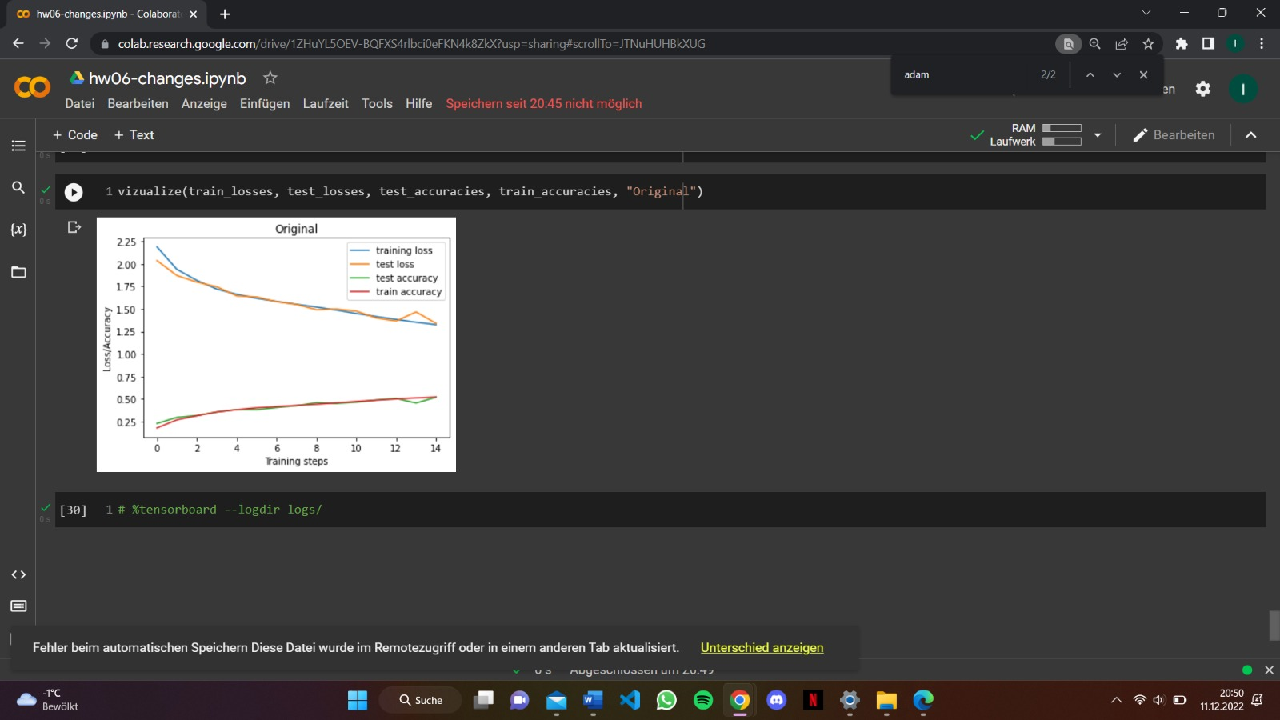

-------------------------------------OPTIMIZER: ADAM----------------------------------------------------------

without training:   
['test_loss: 2.302743434906006', 'test_acc: 0.08820000290870667']

Epoch 0:  
['train_loss: 1.6052789688110352', 'train_acc: 0.40233999490737915']  
['test_loss: 1.3489354848861694', 'test_acc: 0.5094000101089478']

Epoch 1:  
['train_loss: 1.2469662427902222', 'train_acc: 0.5518400073051453']  
['test_loss: 1.1591624021530151', 'test_acc: 0.586899995803833']

Epoch 2:  
['train_loss: 1.0686951875686646', 'train_acc: 0.6214399933815002']  
['test_loss: 1.0682923793792725', 'test_acc: 0.6295999884605408']

Epoch 3:  
['train_loss: 0.9860793948173523', 'train_acc: 0.6522200107574463']  
['test_loss: 1.0428568124771118', 'test_acc: 0.6360999941825867']

Epoch 4:  
['train_loss: 0.9211509227752686', 'train_acc: 0.6769800186157227']  
['test_loss: 0.9889391660690308', 'test_acc: 0.6600000262260437']

Epoch 5:  
['train_loss: 0.875316858291626', 'train_acc: 0.6935999989509583']  
['test_loss: 0.9628977179527283', 'test_acc: 0.6765000224113464']

Epoch 6:  
['train_loss: 0.8385721445083618', 'train_acc: 0.7058600187301636']  
['test_loss: 0.9242814779281616', 'test_acc: 0.6786999702453613']

Epoch 7:  
['train_loss: 0.8134625554084778', 'train_acc: 0.714959979057312']  
['test_loss: 0.9207309484481812', 'test_acc: 0.6833000183105469']

Epoch 8:  
['train_loss: 0.7854123115539551', 'train_acc: 0.7242400050163269']  
['test_loss: 0.9829105734825134', 'test_acc: 0.6718999743461609']

Epoch 9:  
['train_loss: 0.7659961581230164', 'train_acc: 0.7312600016593933']  
['test_loss: 0.9138099551200867', 'test_acc: 0.6876999735832214']

Epoch 10:  
['train_loss: 0.7385128140449524', 'train_acc: 0.7415599822998047']  
['test_loss: 0.9632834792137146', 'test_acc: 0.6790000200271606']

Epoch 11:  
['train_loss: 0.7242801785469055', 'train_acc: 0.7473400235176086']  
['test_loss: 0.9605263471603394', 'test_acc: 0.6830000281333923']

Epoch 12:  
['train_loss: 0.699072003364563', 'train_acc: 0.7561399936676025']  
['test_loss: 0.9733397364616394', 'test_acc: 0.677299976348877']

Epoch 13:  
['train_loss: 0.6843994855880737', 'train_acc: 0.7572199702262878']  
['test_loss: 0.9741609692573547', 'test_acc: 0.6854000091552734']

Epoch 14:  
['train_loss: 0.6619966626167297', 'train_acc: 0.7693600058555603']  
['test_loss: 0.9680265188217163', 'test_acc: 0.6866000294685364']

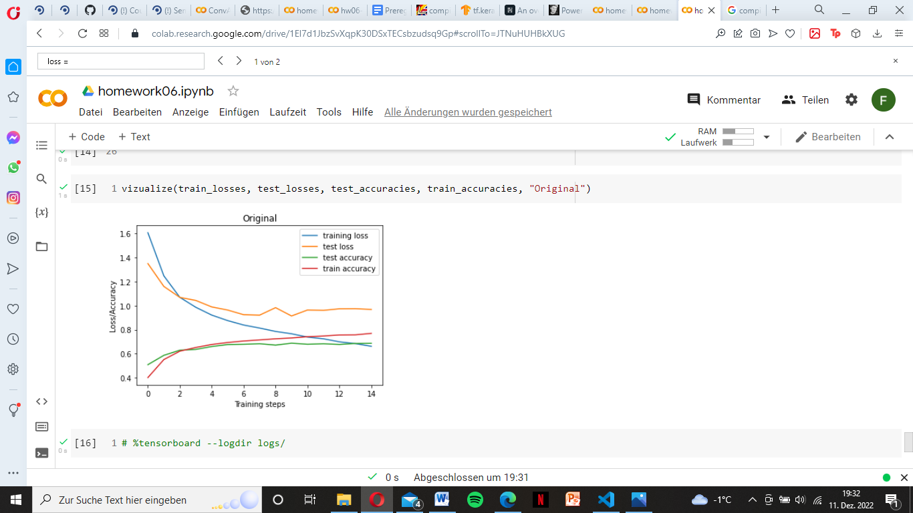

-------------------------------------PENALTIES: L2=0.001-----------------------------------------------------------------

without training:   
['test_loss: 2.465200424194336', 'test_acc: 0.12129999697208405']

Epoch 0:  
['train_loss: 1.9270377159118652', 'train_acc: 0.26471999287605286']  
['test_loss: 1.7778167724609375', 'test_acc: 0.3465000092983246']

Epoch 1:  
['train_loss: 1.8221412897109985', 'train_acc: 0.32401999831199646']  
['test_loss: 1.7805354595184326', 'test_acc: 0.3458000123500824']

Epoch 2:  
['train_loss: 1.7850404977798462', 'train_acc: 0.3450399935245514']  
['test_loss: 1.7263036966323853', 'test_acc: 0.38839998841285706']

Epoch 3:  
['train_loss: 1.776974081993103', 'train_acc: 0.35231998562812805']  
['test_loss: 1.7044451236724854', 'test_acc: 0.4011000096797943']

Epoch 4:  
['train_loss: 1.7673667669296265', 'train_acc: 0.36037999391555786']  
['test_loss: 1.6886658668518066', 'test_acc: 0.3903999924659729']

Epoch 5:  
['train_loss: 1.7615612745285034', 'train_acc: 0.36267998814582825']  
['test_loss: 1.7469215393066406', 'test_acc: 0.37770000100135803']

Epoch 6:  
['train_loss: 1.7635908126831055', 'train_acc: 0.36017999053001404']  
['test_loss: 1.6849169731140137', 'test_acc: 0.3953999876976013']

Epoch 7:  
['train_loss: 1.7601765394210815', 'train_acc: 0.36517998576164246']  
['test_loss: 1.7643134593963623', 'test_acc: 0.3582000136375427']

Epoch 8:  
['train_loss: 1.7599084377288818', 'train_acc: 0.36550000309944153']  
['test_loss: 1.739245891571045', 'test_acc: 0.3921000063419342']

Epoch 9:  
['train_loss: 1.7546604871749878', 'train_acc: 0.3670400083065033']  
['test_loss: 1.6971094608306885', 'test_acc: 0.40560001134872437']

Epoch 10:  
['train_loss: 1.748368501663208', 'train_acc: 0.3705799877643585']  
['test_loss: 1.7751833200454712', 'test_acc: 0.3626999855041504']

Epoch 11:  
['train_loss: 1.7537143230438232', 'train_acc: 0.37064000964164734']  
['test_loss: 1.7033077478408813', 'test_acc: 0.4108000099658966']

Epoch 12:  
['train_loss: 1.7480098009109497', 'train_acc: 0.3744400143623352']  
['test_loss: 1.7595880031585693', 'test_acc: 0.37369999289512634']

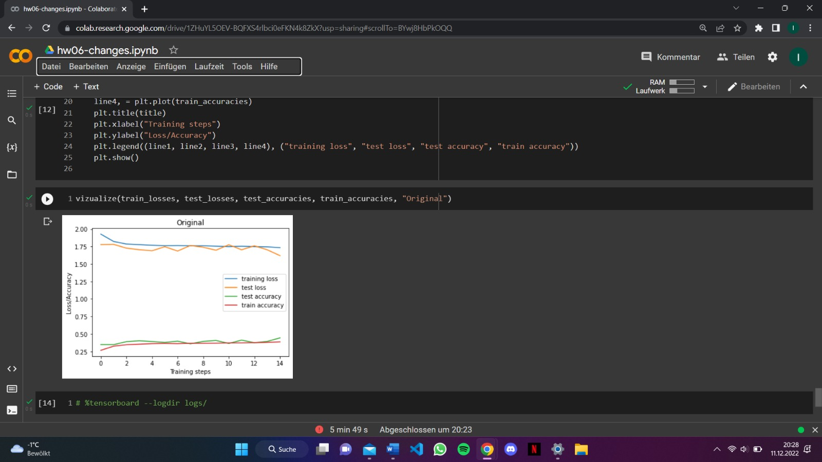

--------------------------------------BATCH NORMALIZATION---------------------------------------------

without training:   
['test_loss: 2.3097872734069824', 'test_acc: 0.09860000014305115']

Epoch 0:  
['train_loss: 1.3410444259643555', 'train_acc: 0.515999972820282']  
['test_loss: 1.0779250860214233', 'test_acc: 0.6136999726295471']

Epoch 1:  
['train_loss: 0.9259251356124878', 'train_acc: 0.6754199862480164']  
['test_loss: 1.032832384109497', 'test_acc: 0.645799994468689']

Epoch 2:  
['train_loss: 0.7852494120597839', 'train_acc: 0.7295200228691101']  
['test_loss: 1.1484549045562744', 'test_acc: 0.6399999856948853']

Epoch 3:  
['train_loss: 0.7042761445045471', 'train_acc: 0.7574800252914429']  
['test_loss: 0.8345330953598022', 'test_acc: 0.7160000205039978']

Epoch 4:  
['train_loss: 0.6501454710960388', 'train_acc: 0.7766799926757812']  
['test_loss: 0.7927079796791077', 'test_acc: 0.7350999712944031']

Epoch 5:  
['train_loss: 0.5993574857711792', 'train_acc: 0.7936400175094604']  
['test_loss: 0.8661393523216248', 'test_acc: 0.7239999771118164']

Epoch 6:  
['train_loss: 0.5686971545219421', 'train_acc: 0.8035600185394287']  
['test_loss: 0.7705539464950562', 'test_acc: 0.743399977684021']

Epoch 7:  
['train_loss: 0.5355183482170105', 'train_acc: 0.8166599869728088']  
['test_loss: 0.7758536338806152', 'test_acc: 0.7538999915122986']

Epoch 8:  
['train_loss: 0.5069458484649658', 'train_acc: 0.8242200016975403']  
['test_loss: 0.8558918833732605', 'test_acc: 0.7311000227928162']

Epoch 9:  
['train_loss: 0.4779280722141266', 'train_acc: 0.8350800275802612']  
['test_loss: 0.7687937021255493', 'test_acc: 0.7649999856948853']

Epoch 10:  
['train_loss: 0.4532869756221771', 'train_acc: 0.841920018196106']  
['test_loss: 0.8127209544181824', 'test_acc: 0.7534999847412109']

Epoch 11:  
['train_loss: 0.4297448694705963', 'train_acc: 0.8487799763679504']  
['test_loss: 0.7345398664474487', 'test_acc: 0.7682999968528748']

Epoch 12:  
['train_loss: 0.41279545426368713', 'train_acc: 0.8558400273323059']  
['test_loss: 0.8975260853767395', 'test_acc: 0.7440000176429749']

Epoch 13:  
['train_loss: 0.390263170003891', 'train_acc: 0.8639199733734131']  
['test_loss: 0.970260739326477', 'test_acc: 0.73580002784729']

Epoch 14:  
['train_loss: 0.3750879764556885', 'train_acc: 0.8689799904823303']  
['test_loss: 0.9894028902053833', 'test_acc: 0.7228000164031982']

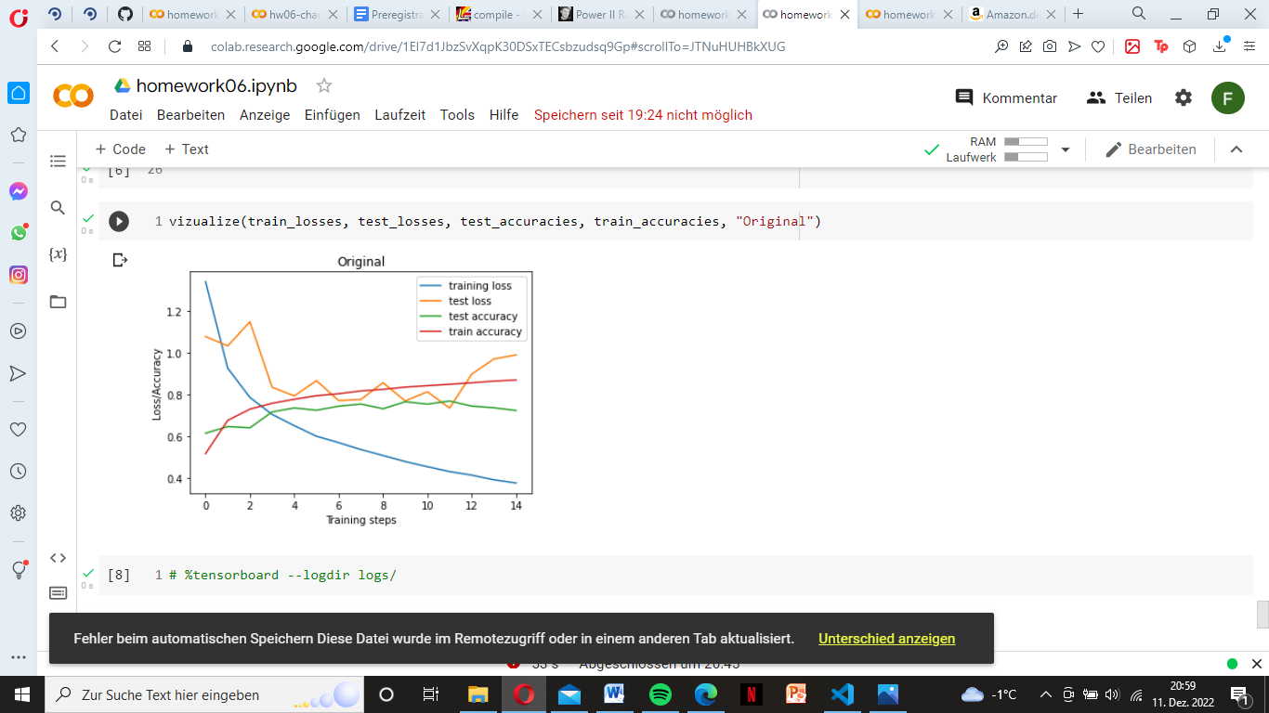

---------------------------------------DROPTOUT = 0.1----------------------------------------------------------------

without training:   
['test_loss: 2.3052525520324707', 'test_acc: 0.09929999709129333']

Epoch 0:  
['train_loss: 1.6655890941619873', 'train_acc: 0.3737199902534485']  
['test_loss: 1.4074002504348755', 'test_acc: 0.4875999987125397']

Epoch 1:  
['train_loss: 1.37638521194458', 'train_acc: 0.5005199909210205']  
['test_loss: 1.310398817062378', 'test_acc: 0.5200999975204468']

Epoch 2:  
['train_loss: 1.2692571878433228', 'train_acc: 0.5443999767303467']  
['test_loss: 1.187121868133545', 'test_acc: 0.5737000107765198']

Epoch 3:  
['train_loss: 1.202559232711792', 'train_acc: 0.5720199942588806']  
['test_loss: 1.0975806713104248', 'test_acc: 0.6054999828338623']

Epoch 4:  
['train_loss: 1.15250825881958', 'train_acc: 0.5904399752616882']  
['test_loss: 1.0980223417282104', 'test_acc: 0.6033999919891357']

Epoch 5:  
['train_loss: 1.125954270362854', 'train_acc: 0.599839985370636']  
['test_loss: 1.0313857793807983', 'test_acc: 0.6310999989509583']

Epoch 6:  
['train_loss: 1.096657395362854', 'train_acc: 0.6137999892234802']  
['test_loss: 1.0136202573776245', 'test_acc: 0.6396999955177307']

Epoch 7:  
['train_loss: 1.0821921825408936', 'train_acc: 0.6178399920463562']  
['test_loss: 1.0394572019577026', 'test_acc: 0.6294999718666077']

Epoch 8:  
['train_loss: 1.0618587732315063', 'train_acc: 0.625819981098175']  
['test_loss: 1.008313536643982', 'test_acc: 0.6420000195503235']

Epoch 9:  
['train_loss: 1.0489264726638794', 'train_acc: 0.6291000247001648']  
['test_loss: 0.9912373423576355', 'test_acc: 0.6481999754905701']

Epoch 10:  
['train_loss: 1.0436779260635376', 'train_acc: 0.6328999996185303']  
['test_loss: 0.969415545463562', 'test_acc: 0.6581000089645386']

Epoch 11:  
['train_loss: 1.0287495851516724', 'train_acc: 0.6387799978256226']  
['test_loss: 0.9822798371315002', 'test_acc: 0.6514999866485596']

Epoch 12:  
['train_loss: 1.0240788459777832', 'train_acc: 0.6382399797439575']  
['test_loss: 0.9529560208320618', 'test_acc: 0.6603999733924866']

Epoch 13:  
['train_loss: 1.016042947769165', 'train_acc: 0.6404600143432617']  
['test_loss: 0.9430384039878845', 'test_acc: 0.6658999919891357']

Epoch 14:  
['train_loss: 1.0052846670150757', 'train_acc: 0.6463800072669983']  
['test_loss: 0.9632994532585144', 'test_acc: 0.6588000059127808']

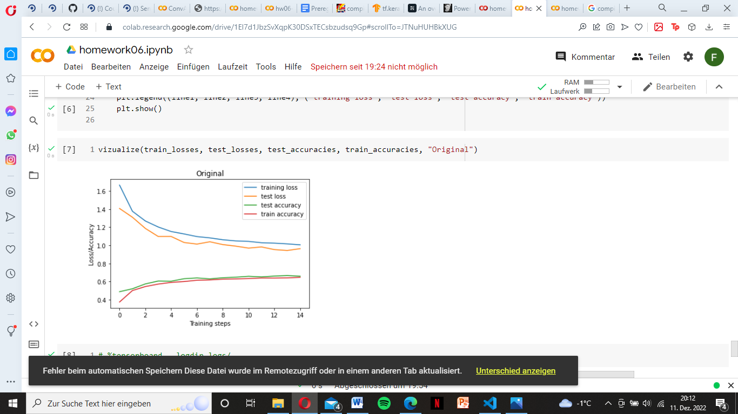

---------------------------------------BATCH SIZE: 15--------------------------------------------------------

without training:   
['test_loss: 2.30464768409729', 'test_acc: 0.10000000149011612']

Epoch 0:  
['train_loss: 1.5949664115905762', 'train_acc: 0.4020000100135803']  
['test_loss: 1.3416974544525146', 'test_acc: 0.5103999972343445']

Epoch 1:  
['train_loss: 1.2440359592437744', 'train_acc: 0.5526000261306763']  
['test_loss: 1.2070059776306152', 'test_acc: 0.569100022315979']

Epoch 2:  
['train_loss: 1.1110775470733643', 'train_acc: 0.6077200174331665']  
['test_loss: 1.121708631515503', 'test_acc: 0.600600004196167']

Epoch 3:  
['train_loss: 1.0237640142440796', 'train_acc: 0.6390799880027771']  
['test_loss: 1.129573941230774', 'test_acc: 0.6039000153541565']

Epoch 4:  
['train_loss: 0.9703936576843262', 'train_acc: 0.6600800156593323']  
['test_loss: 1.0136895179748535', 'test_acc: 0.6496000289916992']

Epoch 5:  
['train_loss: 0.9338503479957581', 'train_acc: 0.6728399991989136']  
['test_loss: 1.0356814861297607', 'test_acc: 0.6452999711036682']

Epoch 6:  
['train_loss: 0.8904805183410645', 'train_acc: 0.6890199780464172']  
['test_loss: 1.0331977605819702', 'test_acc: 0.6546000242233276']

Epoch 7:  
['train_loss: 0.866348385810852', 'train_acc: 0.6986200213432312']  
['test_loss: 1.0346845388412476', 'test_acc: 0.6507999897003174']

Epoch 8:  
['train_loss: 0.8427642583847046', 'train_acc: 0.7049000263214111']  
['test_loss: 1.0536857843399048', 'test_acc: 0.647599995136261']

Epoch 9:  
['train_loss: 0.8215993046760559', 'train_acc: 0.7135400176048279']  
['test_loss: 1.0779082775115967', 'test_acc: 0.6575999855995178']

Epoch 10:  
['train_loss: 0.7970085144042969', 'train_acc: 0.7218599915504456']  
['test_loss: 1.0130233764648438', 'test_acc: 0.6646999716758728']

Epoch 11:  
['train_loss: 0.7806288599967957', 'train_acc: 0.7260400056838989']  
['test_loss: 1.0410982370376587', 'test_acc: 0.6590999960899353']

Epoch 12:  
['train_loss: 0.7595093846321106', 'train_acc: 0.7321799993515015']  
['test_loss: 1.056841492652893', 'test_acc: 0.6568999886512756']

Epoch 13:  
['train_loss: 0.7361542582511902', 'train_acc: 0.7397800087928772']  
['test_loss: 1.1170440912246704', 'test_acc: 0.6603000164031982']

Epoch 14:  
['train_loss: 0.7279383540153503', 'train_acc: 0.7451199889183044']  
['test_loss: 1.0864967107772827', 'test_acc: 0.6639000177383423']

